Branch: MCA (Data Science) | Semester: 2
Student Name: Adarsh Mishra | UID: 25MCD10065
Subject Name: Technical Training - I Lab | Subject Code: 25CAP-652
Section/Group: 25MCD KAR-1 | Date of Performance: 24 Februrary,2026

EXPERIMENT – 05

Aim
To gain hands-on experience in creating and using cursors for row-by-row processing in a database, enabling sequential access and manipulation of query results for complex business logic. (Company Tags: Infosys, Wipro, TCS, Capgemini)

Tools Used
- PostgreSQL

Objectives

Sequential Data Access: To understand how to fetch rows one by one from a result set using cursor mechanisms.

Row-Level Manipulation: To perform specific operations or calculations on individual records that require conditional procedural logic.

Resource Management: To learn the lifecycle of a cursor: Declaring, Opening, Fetching, and importantly, Closing and Deallocating to manage system memory.

Exception Handling: To handle cursor-related errors and performance considerations during large-scale data iteration.

Theory

While SQL is generally set-oriented, certain tasks require a procedural approach where we process one row at a time. This is where Cursors are used:

Cursor Types: Cursors can be Implicit (managed by the system) or Explicit (defined by the developer). They can also be Forward-Only (moving only toward the end) or Scrollable (moving back and forth).

The Lifecycle: * DECLARE: Defines the SQL query for the cursor.

OPEN: Executes the query and establishes the result set.

FETCH: Retrieves a specific row into variables for processing.

CLOSE: Releases the current result set.

DEALLOCATE: Removes the cursor definition from memory.

Use Case: Cursors are ideal for generating row-specific reports, updating balances based on complex historical data, or migrating data where each record needs individual validation
.

Experiment Steps:

Step 1: Implementing a Simple Forward-Only Cursor
Creating a cursor to loop through an Employee table and print individual records.

Step 2: Complex Row-by-Row Manipulation
Using a cursor to update salaries based on a dynamic "Experience-to-Performance" ratio logic.

Step 3: Exception and Status Handling
Ensuring the cursor handles empty result sets or termination signals gracefully.

Query:

Creating Table:
CREATE TABLE employee (
emp_id INT PRIMARY KEY,
emp_name VARCHAR(50),
salary INT
);

-- Step 2: Insert Sample Data
INSERT INTO employee VALUES
(1,'Aman',30000),
(2,'Riya',45000),
(3,'Karan',25000),
(4,'Neha',50000),
(5,'Arjun',28000);

Output:

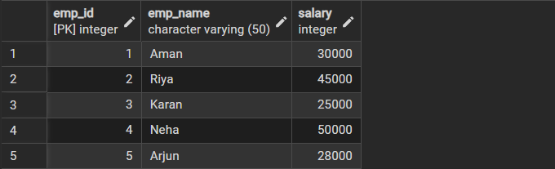

Cursor Procedure:

CREATE OR REPLACE PROCEDURE update_salary_cursor()
LANGUAGE plpgsql
AS $$
DECLARE
emp_record RECORD;
emp_cursor CURSOR FOR
SELECT emp_id, salary FROM employee;
BEGIN
OPEN emp_cursor;
LOOP
FETCH emp_cursor INTO emp_record;
EXIT WHEN NOT FOUND;
-- Business Logic
IF emp_record.salary < 40000 THEN
UPDATE employee
SET salary = salary + (salary * 0.10)
WHERE emp_id = emp_record.emp_id;
END IF;
END LOOP;
CLOSE emp_cursor;
END;
$$;

Call Procedure:

CALL update_salary_cursor();

Displaying Result:

SELECT * FROM employee;

Output:

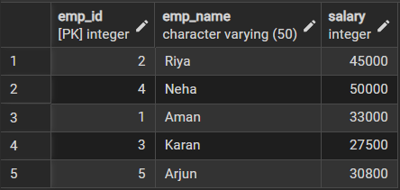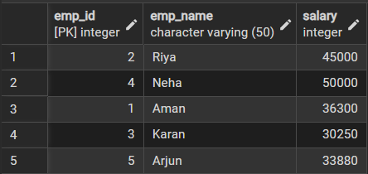

Learning Outcomes:
• Understand the concept and purpose of cursors in PostgreSQL.
• Create and use PL/pgSQL procedures with cursors.
• Perform row-by-row processing on query results.
• Apply conditional logic and data manipulation while fetching records from a cursor.
• Gain practical experience in implementing business logic inside a database.

